**Motion Analysis Results**

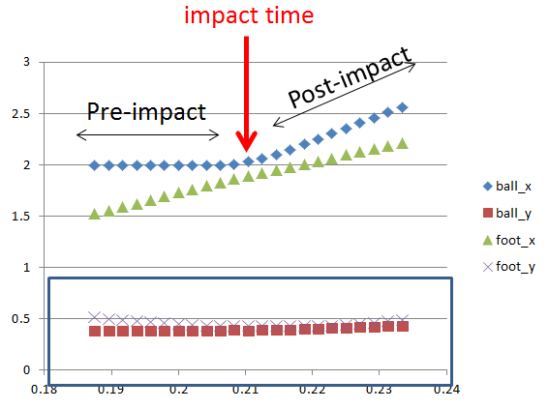

We can ignore results in the y-direction, as height change is almost negligible

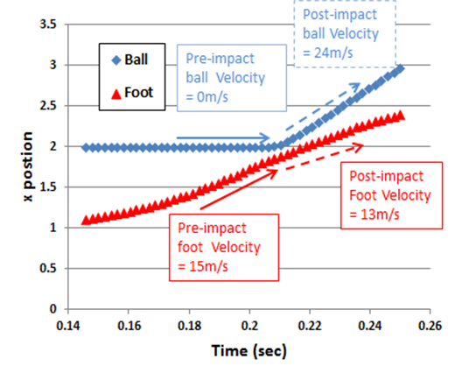

*Also, we know*

Mass of ball: $m_{ball}$*=0.5kg*

*Length of knee-foot: L=0.56m*

*From the EXCEL data plot, you can find*

$$V_{ball_1}=0m/s$$

$$V_{ball_2}=24m/s$$

$V_{foot_1}$*=15m/s*

$$V_{foot_{2}}=13m/s$$

$Coeffieicnt of Restitution: e=\frac{V_{ball_2}-V_{foot_2}}{V_{foot_1}-V_{ball_1}}=\frac{24-13}{15-0}=0.73$

Conservation of the angular momentum:

$H_{knee_1}=I_{leg}ω_{leg_{1}}+I_{ball}ω_{ball_{1}}{=I}_{leg}ω_{leg_{2}}+I_{ball}ω_{ball_{2}}$

$$={I_{leg}\frac{V_{foot_1}}{L}+m_{ball}L^{2}\frac{V_{ball_1}}{L}{=I}_{leg}\frac{V_{foot_2}}{L}+m_{ball}L^{2}\frac{V_{ball_2}}{L}=H}_{knee_2}$$

$$I_{leg}= 1.88kg m^{2}$$

Conclusion

The one of the goals of “biomechanics” is to evaluate to mechanics parameters such as moment of inertia of human body parts without “chopping off” the body parts. With an accurate biomechanics analysis via a fast and low cost digital image-based motion analysis, diagnostic procedure in sports medicine or orthopedics may benefit.